Standardised Breakfast Recipe
A good standardised recipe contains the following information:
1. Menu item name
2. Total number of servings (yield)
3. Portion size
4. List of ingredients
5. Preparation/method section
6. Cooking time and temperature
7. Special instructions, if necessary
8. Recipe cost per portion
Using a standard recipe allows for accurate purchasing and menu costing because you know exactly how much of an item needs to be purchased to make the number of menu items required and you can therefore attribute the right amount of cost to each menu item.
The spreadsheet below can be used for calculating the full cost price of the food on the plate.

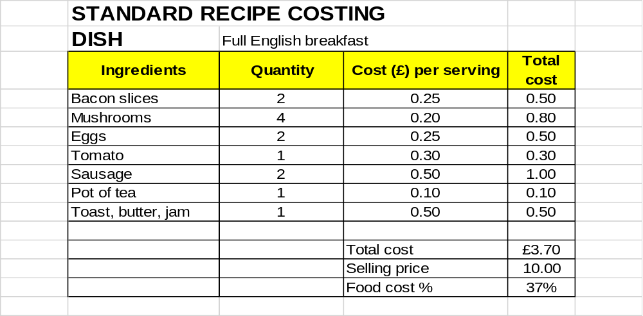
If £10 of the room selling price is allocated to breakfast then the Full English breakfast cost represents 37% of the selling price.
For more advice on controlling food wastage view the resources Prevent Household Food Waste

